Words into Images
Museum Studies Program
Department of Historical Studies
Winter term 2025
István Rév

If you, historians, or poets, or mathematicians had not seen things with your eyes you could not report of them in writing. And if you, 0 poet, tell a story with your pen, the painter with his brush can tell it more easily, with simpler completeness and less tedious to be understood… Now tell me which is the nearer to the actual man: the name of man or the image of the man. The name of man differs in different countries, but his form is never changed but by death…
Leonardo Da Vinci, The Paragone of Painting and Poetry 1500
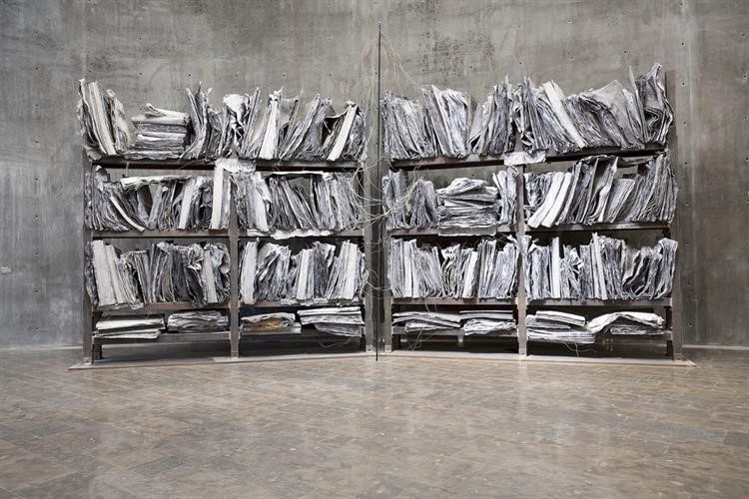

Anselm Kiefer, The High Pristess 1985-89

The course intends to explore the specificities, but also the close family relationships of archives and museums (libraries, as well); explore the possibilities, and also the limits of turning words into images, textual documents into visuals. It deals with words, texts, the tension between literal meaning and figurative excesses, with energeia, the active, activating quality of images, and the evocative character of both textual documents and artifacts. The class follows a selected history and theory of archives; the utopia of collecting, preserving, and presenting universal knowledge, and the efforts of turning textual documents into visual objects, icons, memorials, monuments, installations, moving images. As Aristotle wrote in Poetics: “A verbal representation was said to be persuasive when it gave the impression that it might have been alive”. Examples and practices inside and outside the archives will be studied as well: visual theology, icons that bleed, excrete oil and tears, the vera icon, merging body and image thus creating the “true image”; the myths and problems of photographic images (the fictional character of images that, however, “does not prevent authorities from iris recognition or the surveillance of every sort of public space.”); map making (cartographic and anatomical); political gestures and propaganda; mis-(and dis-)information by images; the use of images as forensic evidence and in legal procedure, especially in grave violations of human rights; etc.
Members of the class will face the problems of the difficulties of authenticating (archival) documents; the diminishing credibility and trustworthiness of archival institutions (and the efforts to restore them), the gains and losses (of authenticity, evidentiary value, and authority) of turning textual documents into images; whether documents turned into images make it difficult to grasp the historicity of texts at a time when the division that separated textual from visual traces of events is becoming thinner by the day.
Members of the class (co-taught by members of the Blinken OSA Archivum, István Rév, Katalin Székely, head of the creative programs at OSA, József Bóné, head of the IT department at OSA) will, besides theoretical issues, get acquainted with technologies that make it possible to turn words into images, exhibitions based on archival material, documents and documentary works. The course will include a day-long excursion to the Archive in Budapest.
The consulted works include texts and (moving) images, in most cases art installations or films with an artistic intent. The class format is a seminar with active participation of the students, who are expected to introduce, and interpret a text or a video in class.
Grades will be based on general classwork (25%), in-class presentation (25%), and an individual, semester-long final project, turning a particular, self-selected document into images (online exhibition, montage, photospread, icon, moving image, etc.)

1st week:
The Archives: the space, the institution, the notion, and the problems.
Reading:
Danilo Kiš, The Encyclopedia of the Dead
https://xpressenglish.com/encyclopedia-of-the-dead/
Cornelia Vismann, Files. Law and Media Technology. Stanford U. P. Stanford, 2008 pp. 55-61, 117-122, 161-164. https://monoskop.org/File:Vismann_Cornelia_Files_Law_and_Media_Technology.pdf

2nd week
Memory in the archive.
Reading:
Jan Assmann, Communicative and Cultural Memory
In: Pál S. Varga – Karl Katschthaler – Donald E. Morse – Miklós Takács (eds.) Loci Memoriae Hungaricae I. pp. 36-43.
https://dea.lib.unideb.hu/server/api/core/bitstreams/524bb96a-d1ae-46e2-bef7-506da8d49697/content#page=22

Aleida Assmann, Transformations between History and Memory.
Social Research: An International Quarterly, Volume 75, Number 1, Spring 2008, pp. 49-72
https://muse.jhu.edu/article/527984/pdf
Optional: Watch Archive Fever - Derrida, Steedman, & the Archival Turn
https://www.youtube.com/watch?v=uHtXeUH4gnY

3rd week
“The Archival Turn.
Reading:
Sara Callahan, When the Dust Has Settled: What Was the Archival Turn, and Is It Still Turning?
https://www.tandfonline.com/doi/epdf/10.1080/00043249.2024.2317690?needAccess=true

Watch: The Note. A chance Event. Online exhibition at OSA

Watch: Anselm Kiefer's Finnegans Wake Exhibition at the White Cube Gallery in Bermondsey, London
Anselm Kiefer's Finnegans Wake Exhibition at the White Cube Gallery in Bermondsey, London - YouTube

4th week
Images of objectivity.
Watch: Objectivity: The Limits of Scientific Sight - Peter L. Galison
https://www.youtube.com/watch?v=QPnJ8ENDNwg
Reading: Lorraine Daston and Peter Galison, The Image of Objectivity. Representations, No. 40, Special Issue: Seeing Science (Autumn, 1992), pp. 81-128
https://cspeech.ucd.ie/Fred/docs/Galison.pdf
Watch: The Pernkopf Atlas
Who Was Eduard Pernkopf?

https://www.youtube.com/watch?v=kkq5OqGxCco&t=344s

The Visible Human Project
https://www.youtube.com/watch?v=7GPB1sjEhIQ

5th week:
Turning words into images.
Read:
W. J. T. Mitchell, Ekphrasis and the Other.
https://complit.utoronto.ca/wp-content/uploads/COL1000-Week11-Nov25_WJT_Mitchell.pdf
Matthew Biro, Representation and Event: Anselm Kiefer, Joseph Beuys, and the Memory of the Holocaust
The Yale Journal of Criticism, Volume 16, Number 1, Spring 2003, pp. 113-146
https://muse.jhu.edu/pub/1/article/41326/pdf

Watch:
Anselm Kiefer’s Germany, Covered in Dust | A Closer Look
https://www.youtube.com/watch?v=AAl91Hc1MKw
Anselm Kiefer: History is a clay
https://www.youtube.com/watch?v=dPEcPn85D8w
Wim Wenders, Anselm
https://www.youtube.com/watch?v=c09sdGYDokI

6th week
A.I. supported tools to turn words into images.
Guest lecture by József Bóné, Chief of IT at Blinken OSA Archivum

7th week

Christian Boltanski’s archives.
Reading: Ernst van Alphen, Visual Archives and the Holocaust: Christian Boltanski, Ydessa Hendeles and Peter Forgacs In: A. Van den Braembussche et al. (eds.) Intercultural Aesthetics: A Worldview Perspective. 2009
David Houston Jones, All the moments of our lives: selfarchiving from Christian Boltanski to lifelogging, Archives and Records, 2015 https://doi.org/10.1080/23257962.2015.1010149
Watch:
Visite exclusive de l'exposition Boltanski | Centre Pompidou
https://www.youtube.com/watch?v=2NMmDmBShyk&t=21s

BOLTANSKI PERSONNES 2010
https://www.youtube.com/watch?v=SXND1GZdBzM&t=128s
Chance by Christian Boltanski: Sydney Festival

https://www.youtube.com/watch?v=0inh2ooFWq0
Christian Boltanski, Danach

https://www.youtube.com/watch?v=_ykDQdEpOU4

8th week
Preview presentation of the individual words-transformed-into-images individual projects in class.

9th week
Turning memories into moving images.
Watch:
Tadeusz Kantor, The Dead Class
kantor_extract-en.pdf

The cart. Fragment of Tadeusz Kantor's 1985 play "Let the Artists Die"

The cart. Fragment of Tadeusz Kantor's 1985 play "Let the Artists Die"
Andrzej Wajda, Umarla klasa [Dead Class] (1977) by Andrzej Wajda, Clip: The dead class bring in their former selves
Umarla klasa [Dead Class] (1977) by Andrzej Wajda, Clip: The dead class bring in their former selves
Recommended to watch:
Tadeusz Kantor: The Dead Class the full-length film by Adrzej Wajda
Tadeusz Kantor "Umarła klasa" (Dead class) [English subtitles]
10th week
Turning archival sources into art and vice versa.
Watch: Forensic Architecture
German Colonial Genocide in Namibia, Shark Island
German Colonial Genocide In Namibia: Shark Island ← Forensic Architecture
Triple-chaser by Forensic Architecture
https://forensic-architecture.org/investigation/triple-chaser
Blank paper becomes symbol of China’s protests - BBC News
https://www.youtube.com/watch?v=IbdCaaW2cDc

11th week
The other way round: images into words
Reading: James A. W. Heffernan, Museum of Words. The Poetics of Ekphrasis from Homer to Ashbery. The U. of Chicago P. Chicago 1993. pp. 1-9.
https://books.google.hu/books?id=z9IfT4xl_tAC&printsec=frontcover&source=gbs_ge_summary_r&cad=0#v=onepage&q&f=true

Carlo Ginzburg, EKPHRASIS AND QUOTATION Tijdschrift voor Filosofie , March 1988, Nr. 1, pp. 3-19
https://www.jstor.org/stable/pdf/40885536.pdf?refreqid=fastly-default%3Aae339f696df870ed85c53baf1ccdbdf4&ab_segments=&initiator=&acceptTC=1
Listen: The Trial. A Memorialization of words. A Memorial. Week-long audio public program at OSA, 2008

