Title The revolution boys
Logline: a group of school kids 14-15 years old, get enthusiastic from the news of other Arab counties protests and revolutions, and they draw graffiti on their school wall. The kids later are arrested by the regime and tortured. Then, protests start all over the county.

The Pitch:
In the southern city of Daraa, commonly called the "Cradle of the Syrian Revolution", protests had been triggered on 6 March by the incarceration and torture of 15 young pupils from prominent families who were arrested for writing anti-government graffiti in the city, reading: "الشعب يريد إسقاط النظام" – ("The people want the fall of the regime") – a trademark slogan of the Arab Spring. The boys also spray-painted the graffiti "Your turn, Doctor"; directly alluding to Bashar al-Assad. Security forces swiftly responded by rounding up the alleged perpetrators and detaining them for more than a month, which set off large-scale protests in Daraa Governorate that quickly spread to other provinces.
the Characters
Mouawiya Syasneh: young guy strong face expressions, he tells the story how the Syrian revolution began and how he was part of it.
Group of boys: enthusiastic school children from the governorate of Darra in Syria, with full of energy and motivation to change, encouraged by the anti-regime uprisings taking place at the time in Tunisia and Egypt
Group of people in protests: people in protests full of anger and power to change the regime peacefully.
Security policemen: people in policemen dress with rough features.

the Summary

1st act: a view of an interview with the young man Mouawiya who was part of the revolution, he starts telling about the start of the revolution and how his mates and he planned to draw graffiti on the school wall. During the interview, he has a flashback in time, when the event happened.
2nd act: A group of school children discuss among themselves what is going on in the Arab counties and the revolutions that already started. Mouawiya and his friends decided to spray-paint the slogan after being harassed by police stationed near their school. One of them tells the others that we need to change the regime. His school mate replies saying that what is about writing on the school wall at night. Then they decide to buy paints pray and do that in the following night. They write " 'Freedom. Down with the regime. Your turn, Doctor'," referring to President Bashar al-Assad. The security forces responded promptly by arresting the alleged perpetrators and holding them for more than a month, in turn prompting local demonstrations that called for their release. It sparked widespread protests in Daraa Governorate. After they are released, one had lost an eye while several had fractured skulls and all had at least one broken limb.
3rd act: minor protests happen elsewhere in the country. Protesters demand the release of political prisoners, more freedoms, and an end to pervasive government corruption. The events lead to large-scale protests breaking out in several cities, including Banias, Damascus, al-Hasakah, Daraa, Deir az-Zor, and Hama. (illustrated by a map) Police responds to the protests with tear gas, water cannons, and beatings.

Comments

The story is starting to take a specific shape so well done on that. beatings. As it is the story is too big for the format you have. Our suggestion be to remain with the first act as the setting with the interview and the flashback. Act 2 does not need all the background of the kids discussion and decision but it should be a flashback to the site and the night of the graffiti. Maybe there you can have them talking to each other and explaining why they are doing what they are. Act 2 should end with the police lights or something like that and the boys hearing you are under arrest. That would be more than enough for a reader to understand the story. Maybe if you want to show that some of them were killed (were they) you can do so in a double page with their faces being crossed of and the voice from the interview explaining what happened and that someone them were released.
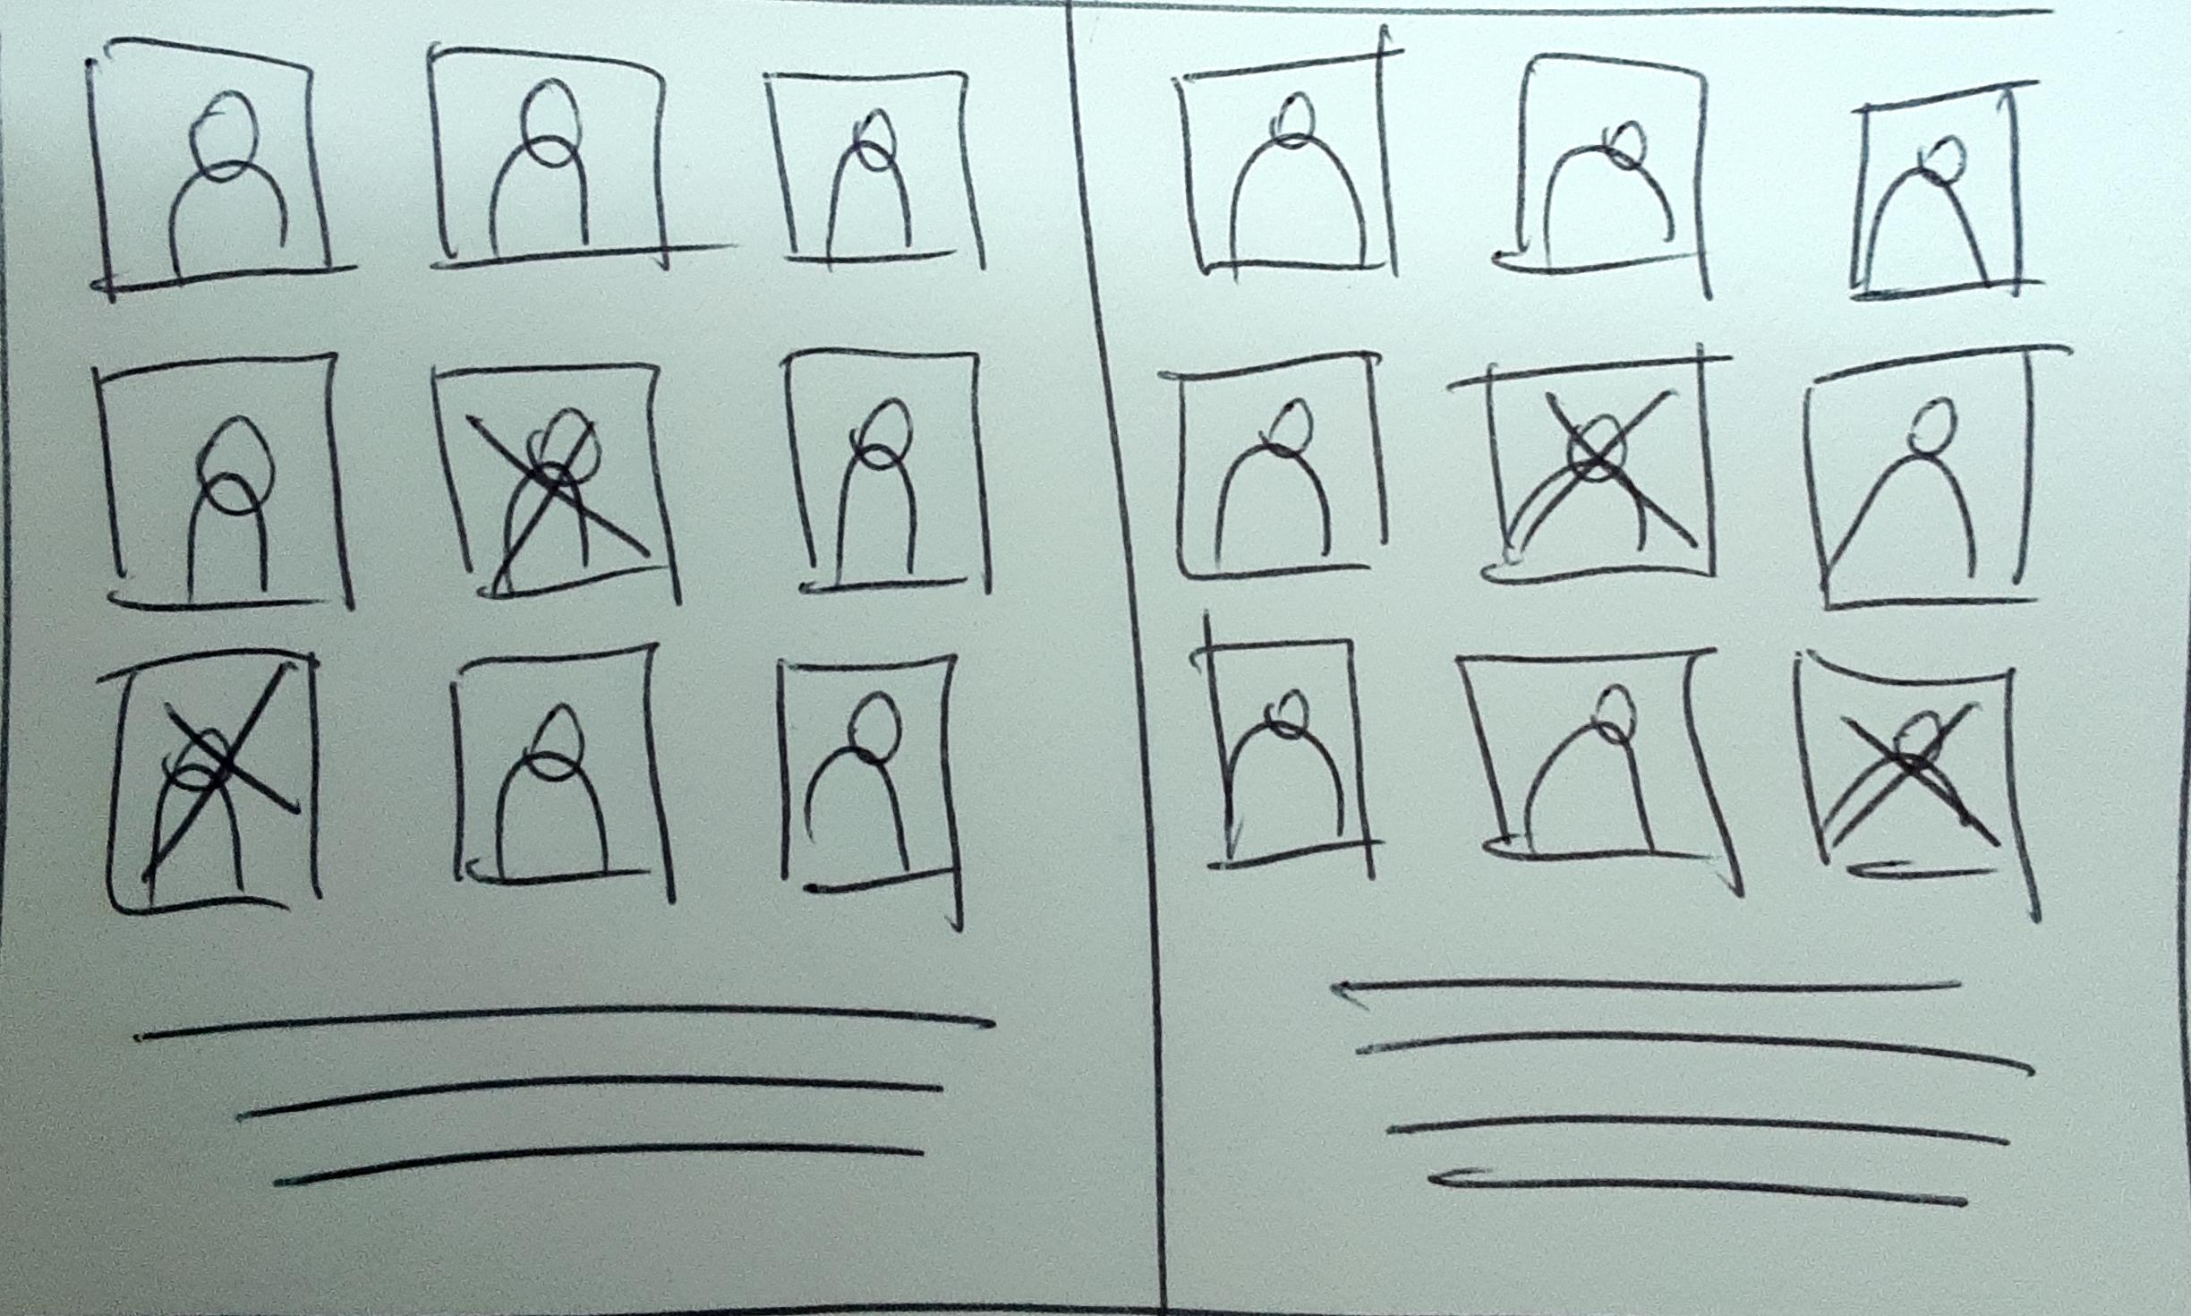

Act 3 does not need as well to be as diastolic you can use 1 or 2 pages to show that the protest spread without actually telling all of it or describing the protests but simply having a page with the same graffiti appearing in many different cities around the country. The reader would understand this without much description. If you want you can even use a map here or photographic material you may have

Finally you should close back to the interview with the kid who is now a man.

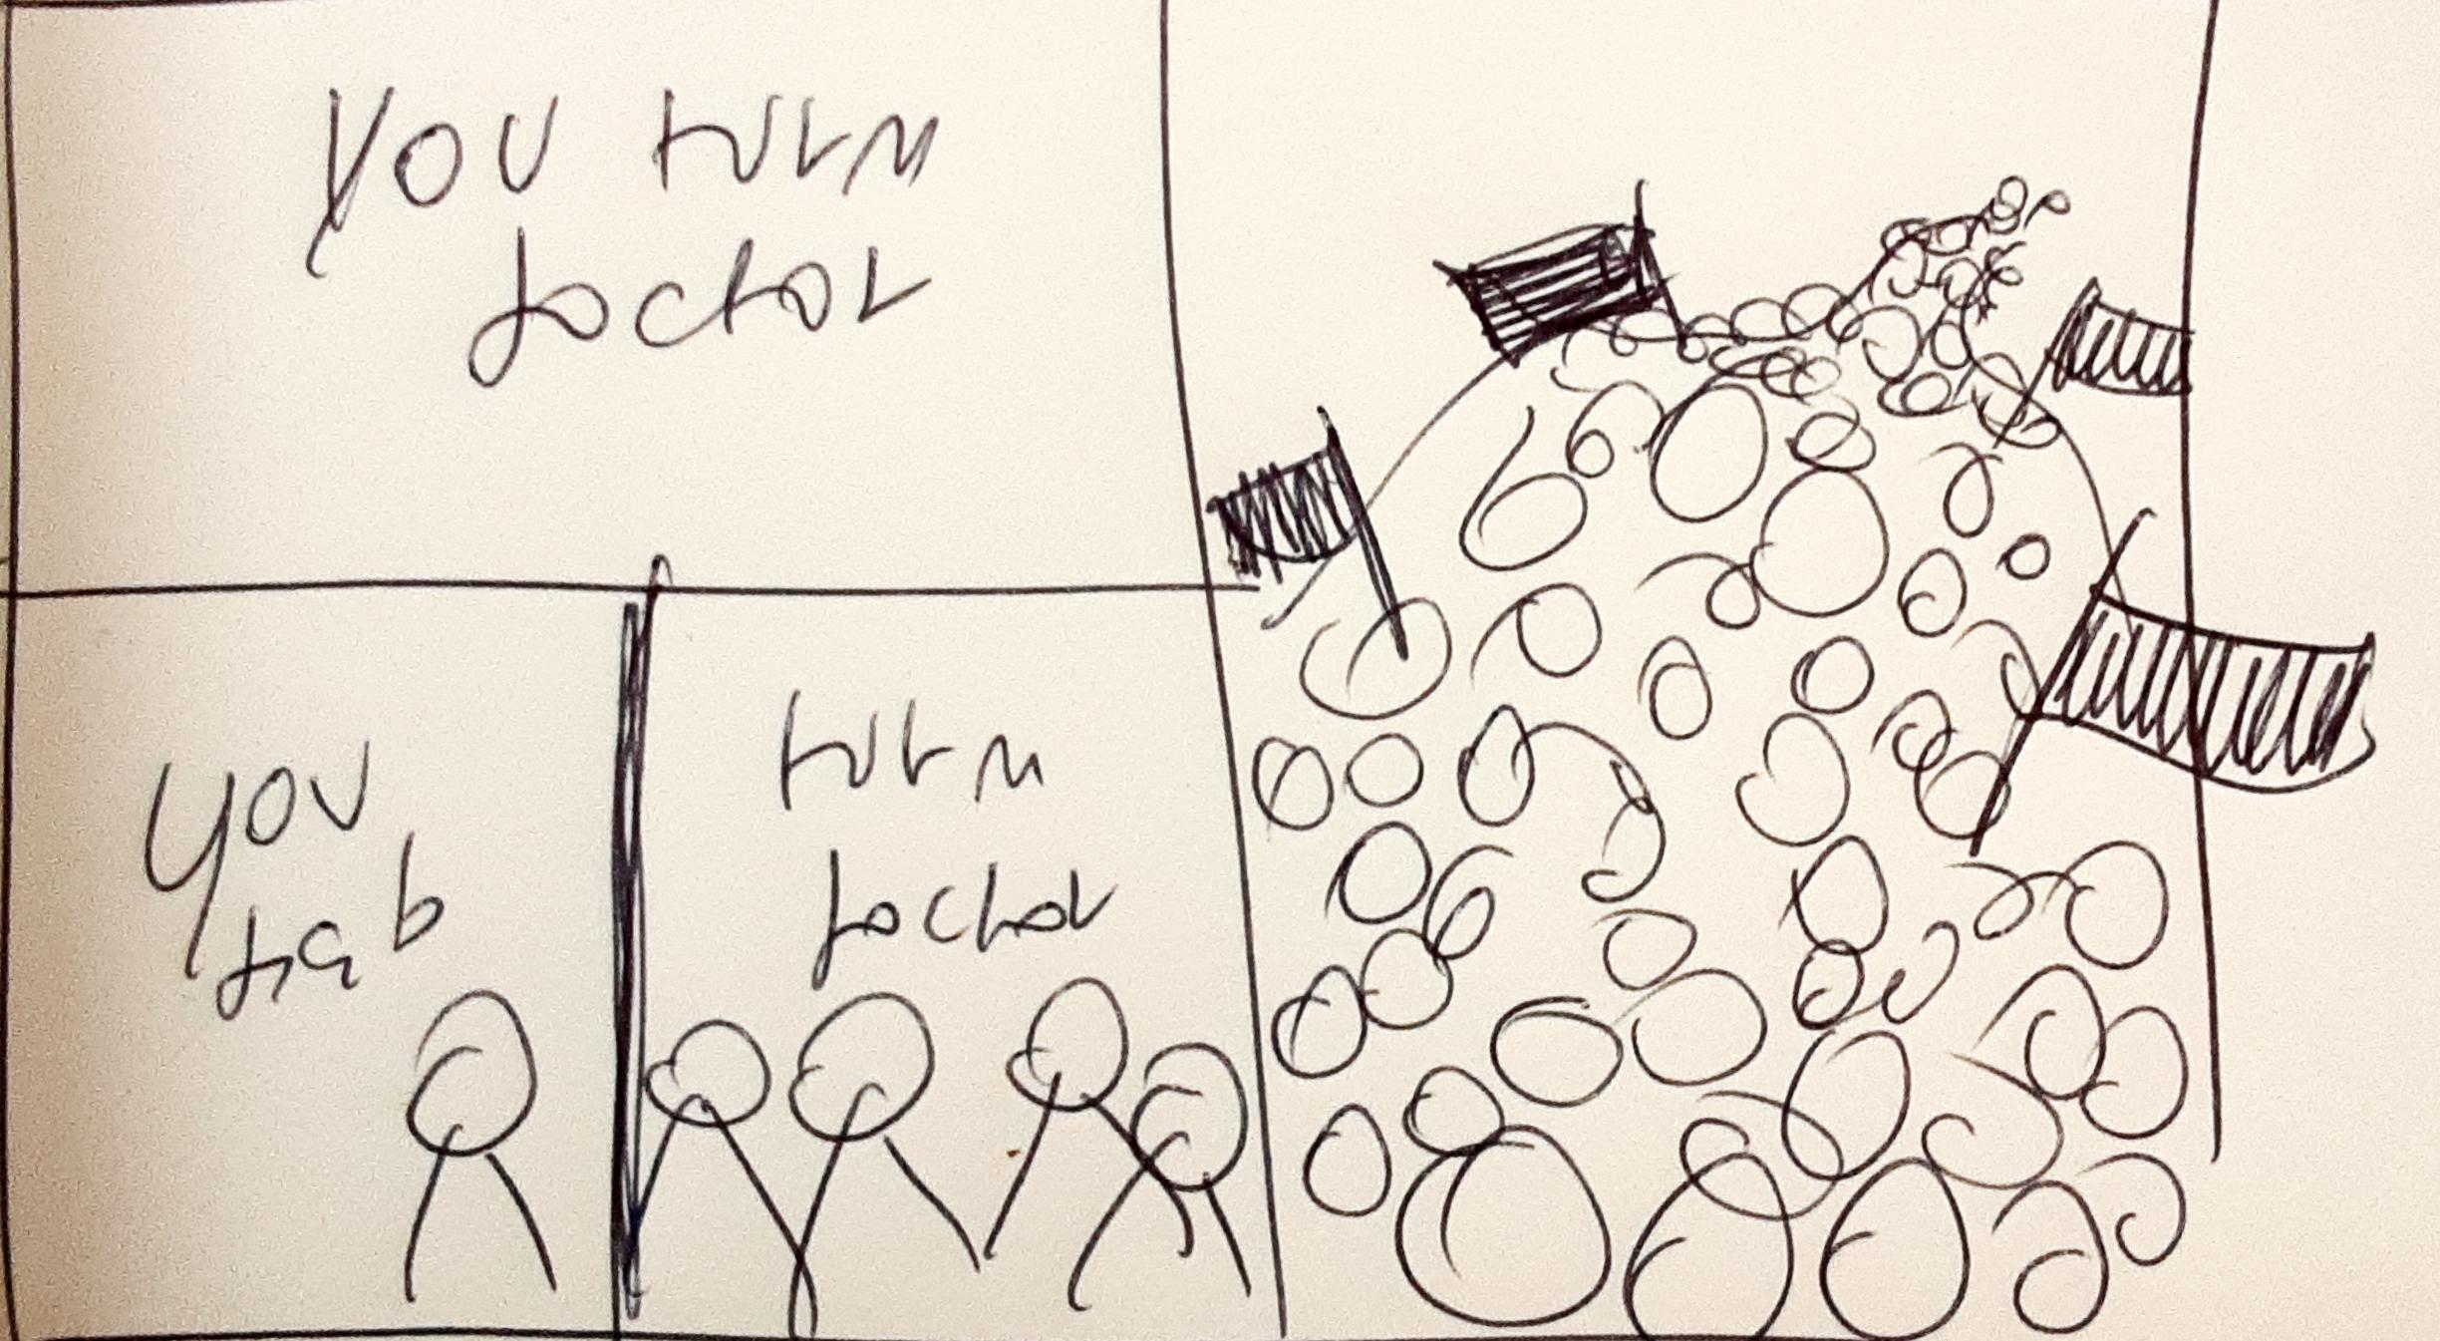

If this structure works for you the next step is to think of each scene and the plot sequence as we will discuss in class.

