Graphic story SUBJECT
Title: Foraging for freedom [provisional]
Logline: A discussion in a vast pine forest in Oregon, US, about what freedom means and how differently it can be imagined, based on the stories of four mushroom pickers from various walks of life, all of them having different experiences of war and displacement – given to us through by a narrative voice.
Pitch: Matsutake is a rare mushroom from Japan known for its distinctive taste and extremely high economic value, that, surprisingly, thrives in landscapes ruined by industrial capitalist disturbance. This peculiar commodity attracts many people from all sorts of backgrounds to an industrial pine forest with a long history of logging in Oregon, US, to forage for mushrooms even under highly dangerous and precarious circumstances. The forest is busy with people looking for matsutake and exchanging them for money. Yet it is not merely the promise of economic gain that motivates pickers to hunt for matsutake: for them, this form of life also symbolises the possibility of freedom. But what freedom is, and how it is imagined is differentially informed by pickers’ life experiences and culturally specific engagements with the traumas of war and displacement. As mushroom pickers forage for matsutake, we learn from a narrator that freedom emerges from open-ended cultural interplay, full of potential conflict and misunderstanding between white American veterans, and war refugees and immigrants from South Asia. However, as we get to know a fourth forager, and undocumented Latino picker, it becomes clear that not everyone shares the rhetoric of freedom, and for some people, living in the forest to make a living from matsutake commerce is only that: a survival strategy. We are left with the conclusion that while the pursuit of freedom is a strong incentive for mushroom pickers, even at the apparent end of the world in a remote forest, freedom is not a universally attainable state but something that is conditional upon structural factors.
Characters:
- Jeff – a grumpy White American war veteran of US-Indochina war, who prides himself on self-sufficiency and his ‘hunting skills’. He imagines himself not only as a violent vet but also as a self-sufficient mountain man: loner, tough, and resourceful. He prefers to forage alone, away from the others, to minimize the chances of triggering flashbacks but also because his patriotism has white supremacist undertones that keeps him from mingling with South Asian pickers
- Seng - a Lao refugee from Vietnam who was supposed to enlist in the army but instead fled the country to seek out opportunities for a new life in the US. Disappointed with the new country that promised him freedom but instead crowded him into a tiny urban apartment and forced him to obey a boss, he fled the city. He enjoys the pleasures of illegal picking and the economic benefits that come with it, and thinks of mushroom commerce as an entrepreneurial sport.
- Dara - a Cambodian woman who escaped the traumas of the civil war and Khmer Rouge regime through a UN mission after having one of her legs blown off by a land mine, then subsequently had to navigate the US as it was shutting down its welfare programs in the 1980s. Without any prospects of stable jobs and benefits, she decided to make a living through mushroom foraging. She thinks of this lifestyle as having brought back her health, where she can heal from war and sees mushroom picking as an affirmation of her mobility.
- anonymous man – an undocumented Latino migrant who does not share the rhetoric of freedom. For him, matsutake foraging has to be fit into a year-round schedule of outdoor work. During mushroom season he lives hidden in the forest instead of in the legally required industrial camps and motels where identification and picking permits might be checked – as such, for him, being in the forest is not an enactment of freedom but a survival strategy to stay out of the way of authorities.
Summary: [note: I know that this part is the least developed, I will continue working in this]
- 1st act: establishing shot of the forest and the mushrooms, introducing scene and the multiplicity of actors in it. We get a sense of the environment (a remote pine forest in the mountains of Oregon, US), and a closer panel reveals that is in fact busy with mushroom pickers. We find out that the forest is a site for mushroom commerce, where people have found refuge in the woods and try to make a living by selling matsutake at night in a makeshift marketplace. The end of the first act hints at the fact that mushroom picking symbolises something bigger.
- 2nd act: We are introduced to three pickers (Jeff, Seng and Dara) and how they ended up in the forest, and come to learn that despite their completely different life experiences, they share a common vocabulary of freedom. Although informed by different understandings, their desires for freedom is enacted through mushroom picking.
- 3rd act: In this act, we meet a fourth character, an unnamed Latino picker, whose reasons to be in Oregon offers a contrasting experience to those characters who have found freedom in matsutake foraging.
- 4th act: What then, is freedom? having met our characters, this (or something similar to this) is the question that will open the last act. In this act, I would like to pull some strands together, maybe juxtapose again the different characters and offer some concluding remarks on how these encounters around matsutake reveal different ways in which freedom can be understood/achieved.

Comments:

Luca thanks for developing the idea further. It is a bit clearer but it also seems like a story is a bit missing. It feels a bit like a tableau of people with a theoretical conclusion at the end rather than a narrative structure.

Let s start from the setting. First we need to build a setting that focus on the mushrooms as they the main connectors of your characters, for instance something like this in which you can start to see hands reaching from them and then setup the different characters all in the woods.

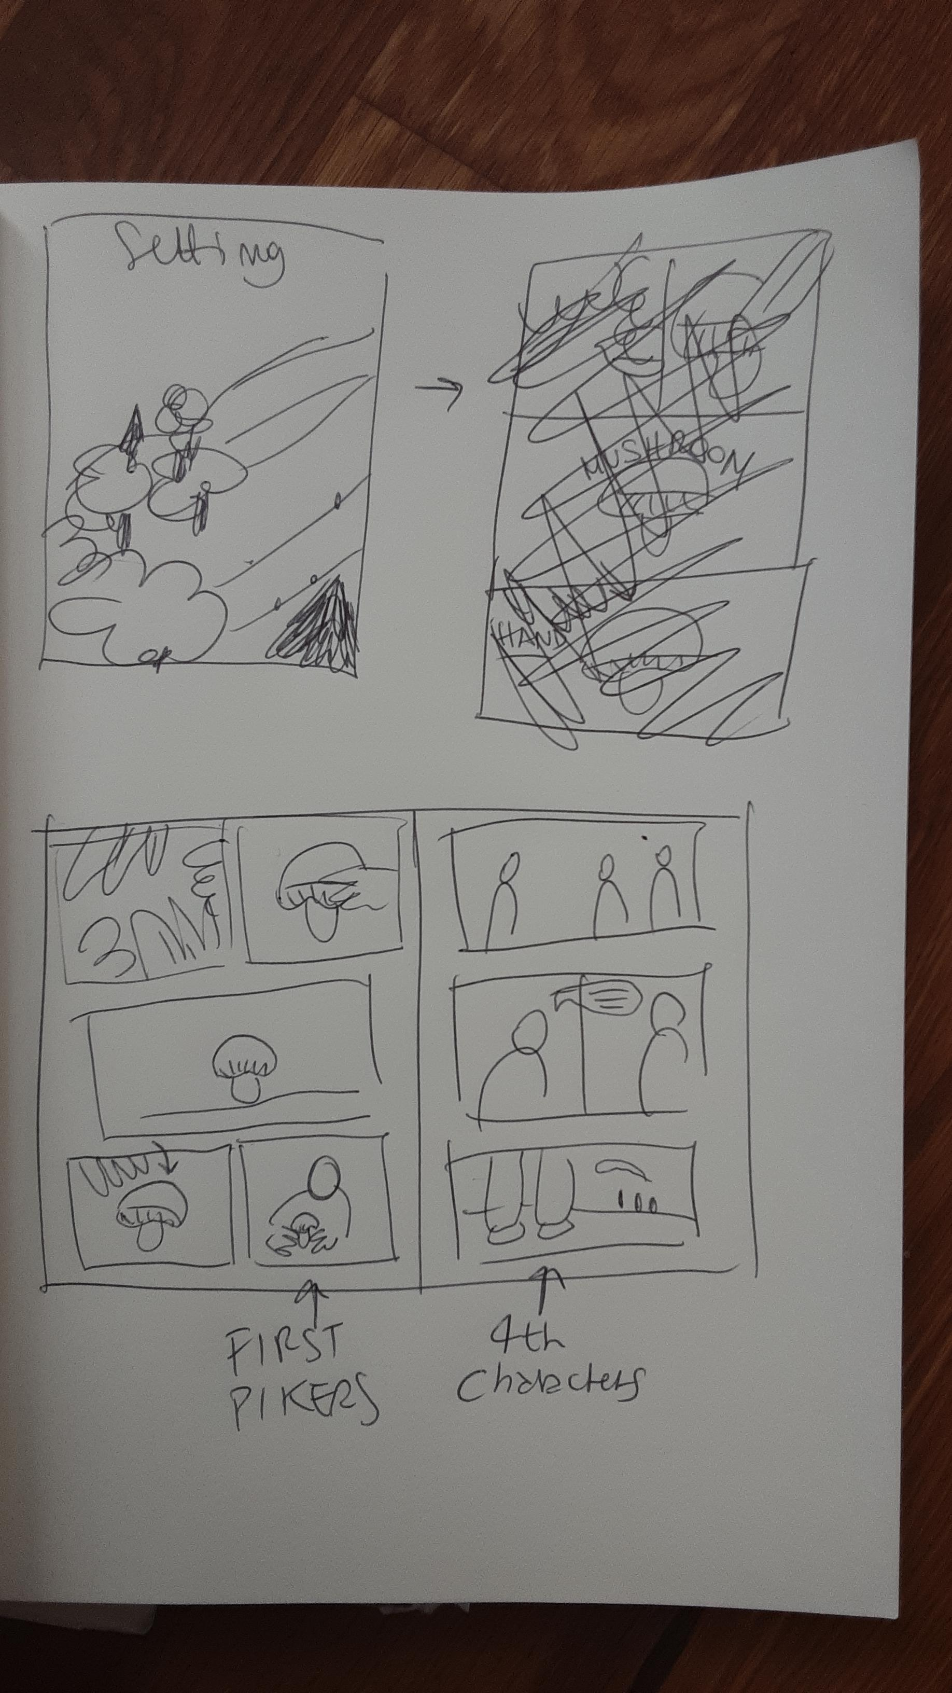
Now as you (not that you have to use exactly this setting) but this set up already would take about 3 pages so rather than then move to each of the characters and have all of them tell their stories and then add a act 4 to talk about freedom maybe you can use character 4, somehow the outlier, to bring up a conflict. For instance, maybe the forth character tells the other this is his spot, and the other start talking about their freedom to do this. Or he tells them that they need to move along, or something like that that generates a tension around the concept of freedom, so maybe their respond by telling specific things about how they got there, how their personal background, cultures, histories.

This is what is somewhat missing a escamotage that allows their story to come out organically and not as a sequence of disconnected characters. What do you think of this ? Let s talk in class.

