The story starts in the southern city of Daraa, Syria, commonly called the "Cradle of the Syrian Revolution", protests had been triggered on 6 March,2011 by the incarceration and torture of 15 young students from prominent families who were arrested for writing anti-government graffiti in the city, reading: "الشعب يريد إسقاط النظام" – ("The people want the fall of the regime") – a trademark slogan of the Arab Spring. The boys also spray-painted the graffiti "Your turn, Doctor"; directly alluding to Bashar al-Assad. Security forces swiftly responded by rounding up the alleged perpetrators and detaining them for more than a month, which set off large-scale protests in Daraa Governorate that quickly spread to other provinces. The Syrian Arab Army was soon deployed to shoot at the protests; resulting in a popular resistance movement led by locals; which made Daraa one of the first provinces in Syria to break free of regime control.
The characters are school students, security forces, policemen and protestors. The main character is one of the kids, he is interviewed. I am going to include quotes from him explaining how the spark of the revolution started and what happened when they drew the graffiti and being arrested.
I am thinking in presenting it in a way of flashback after a question asked to the main character. I am working on the layout of the story, but it is still as a draft. So, I am going to focus on the following steps:
- When the kids decided to buy the paint sprays
- Kids planning and drawing the graffiti
- Arrest from the regime security and policemen
- Demonstration and upraising in the governorate
- Spreading the upraising to the rest of the country (Map)

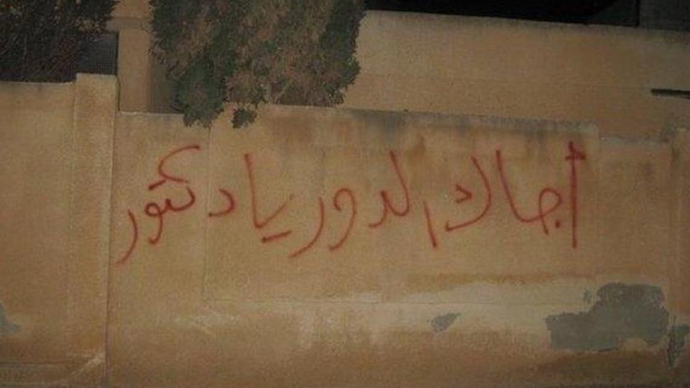
The graffiti photo
COMMENTS:

Thanks for sending this. As we discussed in the lab with you, as it is the story is a bit too wide and extensive for what you can in the pages provided.
First all of, what is the main intention behind you telling this story? Do you want to show the power of this kids challenge to the regime and free speech? Is it about police repression? Is it to recover and tell the story of the spark that ignited the revolution?
For this length you need to choose one and that build the story around that intent.
Our suggestion is to concentrate on the kids, their graffiti and specifically on the phrase "Your turn, Doctor"; as this was a direct connection and addressing by a group od children to Bashar al-Assad. First this is the power of graffiti, this ability to cut through the noise and shout something. Secondly, this act is also ultimately what the Syrian revolution was about, addressing directly a very powerful man and his system.
In this sense, rather than narrating every step of this story from the graffiti to the protest, which would be impossible in these pages, you could focus on the story of the main characters and their first graffiti and then suggest the importance for the protest, even simply having one shot of the protest with the same graffiti in the middle.
If you decide to use the interview as the main narrative structure this could be the hook for the flashbacks. You can have a question from the journalist and from there develop the past action, this could be the question originally asked or some somewhat made up question that allow the characters to start telling the story for the point of view of a boy.
For instance, if you decide that your intent is to tell the story of how the revolution started you may have the journalist setting that up and then use that question to flashback to how the kids, in their own words, in their own modes of speaking, and in their school decided to produce the graffiti.
Obviously, if the intents is a different one that would mean changing both which part of the story you tell and how is it set up.
As a next step, we suggest you reduce to one part of this story and tell us in different ACTS what each of them does so to start giving a more clear structure on the model of what we discussed in class.

