INTRODUCTION TO ZOTERO

- Basic guidelines to Zotero

Bibliographic management software www.zotero.org
Download: (Desktop icon, connector, word toolbar)

- Structure
- Folders (create new)
- Sources (source types)
- Metadata
- Create bibliography, Cite While You Write plugin
Example for the correct form of a bibliographic reference in Chicago (author-date) style:
Turner, Stephen. 2021. “Explaining Away Crime: The Race Narrative in American Sociology and Ethical Theory.” European Journal of Social Theory 24 (3): 356–73. https://doi.org/10.1177/1368431020982534.

- How to collect sources into Zotero?
- From the Web; create a folder and save with Zotero connector
Example with Global Search:
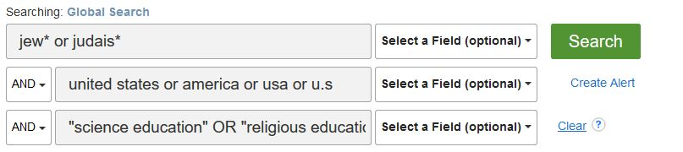
- Manually
- By ISBN or DOI number
Example for ISBN: 9781108483018
Békés, Gábor, and Gábor Kézdi. 2021. Data Analysis for Business, Economics, and Policy. Cambridge: Cambridge University Press.

Example for DOI: 10.19181/socjour.2019.25.3.6677
Krihtova, Tatiana M. 2019. “Sociology of Family and Childhood in the Work of James Bossard.” Sociological Journal 25 (3): 84–98. https://doi.org/10.19181/socjour.2019.25.3.6677.

Saving book chapters: change item type to book section; add author, title, page numbers. www.worldcat.org: good for saving book records into Zotero.

Example for a book chapter:
Okagbue, Osy A. 2021. “In the Prison of Their Skins: Performing Race in Caribbean Theatre.” Electronic resource. In The Palgrave Handbook of Theatre and Race, edited by Tiziana Morosetti and Osy A. Okagbue, 239–54. Basingstoke: Palgrave Macmillan. https://ebookcentral.proquest.com/lib/centraleurope-ebooks/detail.action?docID=6566985.

Activity: Search for a Topic in Global Search. Save 10 items into Zotero. Open a word document.
Insert citations and bibliographies.
- How to collect PDFs into Zotero?
- From PC 1 proper 1 (not Create Parent Item)
Example with Google Scholar: towns and cities
- Full text availability through link resolvers
- Save into Zotero with the connector

Activity: Save PDFs from your computer or from Google Scholar into Zotero.
- Special Features in Zotero
- Built-in PDF editor replacing Zotfile. Extract annotations by right-clicking on parent item: Add Note from Annotations.
Activity: Add highlights and notes to a PDF in Zotero. Extract annotations.
- Tagging and Color-Coding in Zotero
- Online account: synchronize data
- Get Help
- Libguides: Using Zotero to Manage Your Research Sources https://ceu.libguides.com/zotero
- Citing Sources and Academic Integrity
https://ceu.libguides.com/citing
- CEU Library tutorials
https://library.ceu.edu/help/tutorials/
- Face-to-face consultation
https://library.ceu.edu/help/database-training/
- Zotero Documentation and Forums
https://www.zotero.org/support/
https://forums.zotero.org/discussions

Specific databases relevant for Sociology and Social Anthropology
- Sage Research Methods Online
1.1. Find documents that mentions constructivist grounded theory

  - Explore the Project Planner for a few minutes. What do you think this tool does?
Methods map – Qualitative research / Ethnography/Fieldwork/Thick description

2. ProQuest Dissertations & Theses Global: The Humanities and Social Sciences Collection
Find theses discussing how identity is formed by migration
ab(migration) AND ab(identity) AND ab(narrat* or storytelling)
more advanced
ft(migration near/10 identity) AND ab(narrat* OR storytelling)
3. Lexis Nexis Academic

Activity: Data breaches and cybercrime
Activity: find recent (not older than a year) news materials dealing with segregation in education.
HLEAD(segregation w/5 education) + date available + 1 year

4. Statistical sources
4.1. wiiw databases
Activity:
Check in which country in the region you can see the highest average monthly wage (in EUR) in the “arts, entertainment and recreation” sector.

Annual database - Average monthly net wages by activities
4.2. Cross-National Time-Series Data Archive
Activity :
Check what variables are included in the category of Urbanization Data

5. Sources with extensive data coverage plus books, articles, working papers
5.1. IMF eLibrary Complete
Activity: find out what type of contents are available related to Discrimination and Race relations

5.2. OECD iLibrary trial access for most of the themes until 31 December 2018
Explore the theme Social Issues/Migration/Health
OECD Social and Welfare Statistics/Income distribution
Find data for the mean disposable income for total population in Germany between 2011-2015

