Great Gig in the Sky
Script

Act 1: (DW enters GC. Inside-outside distinction)
We open with a zoomed out shot of a map showing the contrast between gated community (GC) and the outside, based on this image:
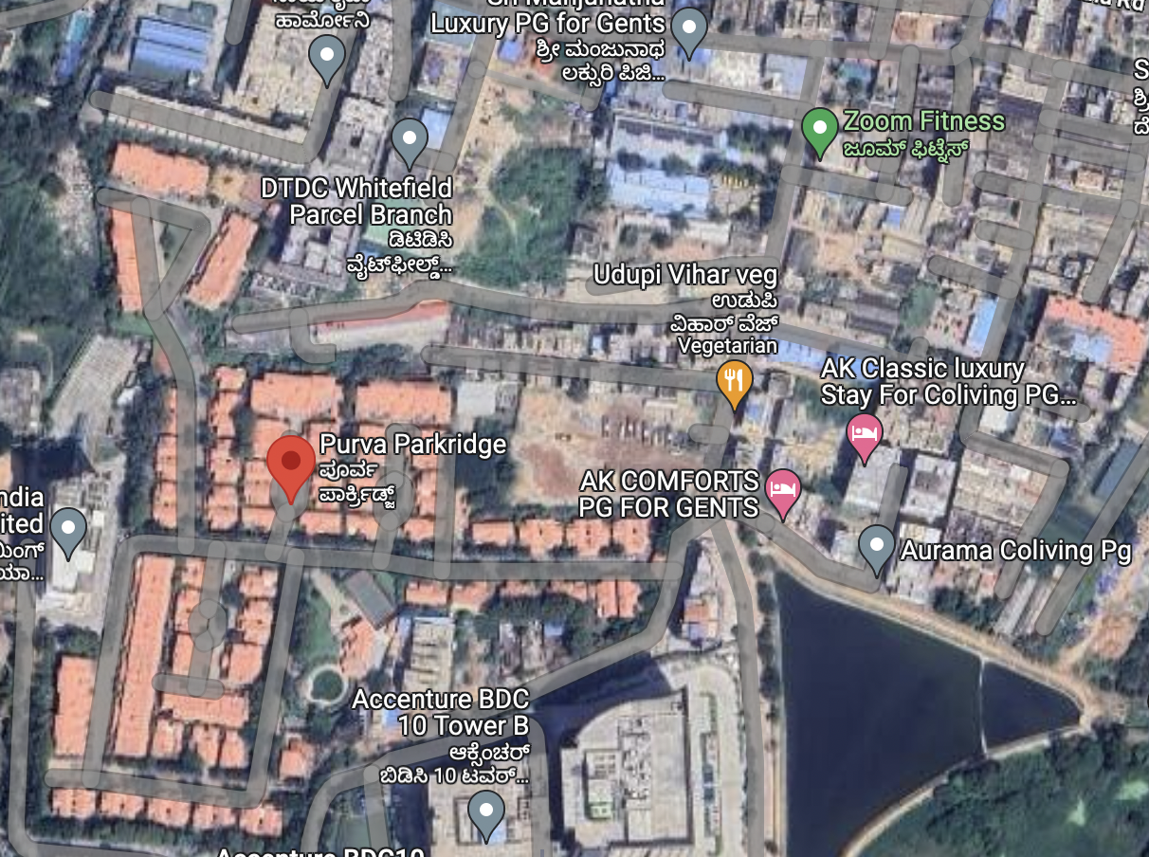

Our main character, the domestic worker (DW), is seen entering the gate. From over her shoulder, we see the contrast between Inside and Outside - the former is colourful and bright, while the outside is dull, in shades of grey, white, and black. The domestic worker, dressed in the traditional Indian sari, her hair tied into a neat bun, is in the same colours of the outside, and stands out from the GC. At the gate, she has to show her ID card before being let inside.
The GC is full of big white houses with red-tiled roofs, wide palm-lined streets, wrought iron street lamps, landscaped gardens, rolling green lawns, and CCTV cameras. DW also passes by a tennis court and community swimming pool on her way to her employer’s house.

Act 2: (DW’s day at work. Setting context for event in next act)
Upon reaching the employer’s house, DW leaves her phone near the door, near another phone.

DW: good morning madam.
Employer: morning! Did you leave your phone outside?
DW: Yes ma’am.
Employer: good, don’t want you distracted while working. Don’t forget the trash like yesterday!

DW walks into the kitchen, to see her coworker already there.

DW 2 (already in kitchen): hey!
DW 1 (walking in): mornin’!
DW 2: finally it’s sunny no? It was getting impossible to dry my husband’s shirts.
DW 1 (picking up trash): you mean his one work shirt?

They laugh as DW1 takes the trash out. On the way, she passes by the employer who is chatting on the phone. The day progresses as DW 1 and 2 do chores around the house. They seem to fade into the background as the employer family goes about their day, playing video games, attending zoom meetings, watching TV.

[splash/hierarchical grid with TV in the centre, showing news about demolitions by municipal government in response to stormwater drains encroachment. Grandfather is watching news, employer walks in. DW 1 and 2 are working in bottom half of page]

Employer: Dad, can you turn the volume down a little?
Grandfather (angrily): But did you see the news?! Crazy that these builders illegally build on top of essential infrastructure that…the city is flooding because the water has nowhere to go, thanks to these guys!
Employer: Yes, but that’s the simple version. Actually the government is in cahoots with them. Builders manipulate stormwater drain maps to show their project is legal, and the government turns a blind eye. (dialogue split in 2-3 panels around TV)
Grandfather: didn’t expect this from reputable builders…almost as bad as those illegal slums. Hmpf!

DW 1 and 2 exchange a look as they go about their tasks.

Later, in the kitchen when they are alone again:
DW 1: Those demolitions…do you think they’ll come for our homes again?
DW 2: Again?
DW 1: Yeah, you remember I grew up in Delhi?
DW 2: mmhm…
DW 1: well, some fancy builder wanted to make a mall where we used to live. So they sent the bulldozers, and…well.
DW 2: baap re (similar to ‘oh my god’).
DW 1: yeah, the whole neighbourhood was gone in a day.
DW 2: you know, I don’t think we’ll have to worry about that here. Here in Bangalore, they’re demolishing because of the flooding. So if our homes don’t flood…
DW 1: …we’re probably safe. True.
DW 2 (giggling): you know where it did flood?
DW 1: hahaha, like they would ever demolish this place!!

Act 3: (main event, resolution and debrief)
Later that day, DW 1 and 2 pick up their phones.
Employer (off camera): see you girls tomorrow! Don’t be late.

They walk towards the gate, through the same landscape as the morning in reverse. As they approach the gate, they see a commotion near the guards’ cabin. They rush towards the gate, as the guards are shouting “no entry” to the policemen trying to come in. A bulldozer is with them.

Guard: Sir, I can’t let you in without a permit.
Policeman: We don’t need permission!

DW 1 pulls DW 2 over to the side as angry GC residents charge towards the gate.

Resident 1: What do you think you’re doing?!
Resident 2: Calm down, dear. (to policeman) sir, it’s true that there was flooding here. But we’re the victims of encroachment from outside. Why are you…
Policeman: orders, sir. (to bulldozer) Move forward!

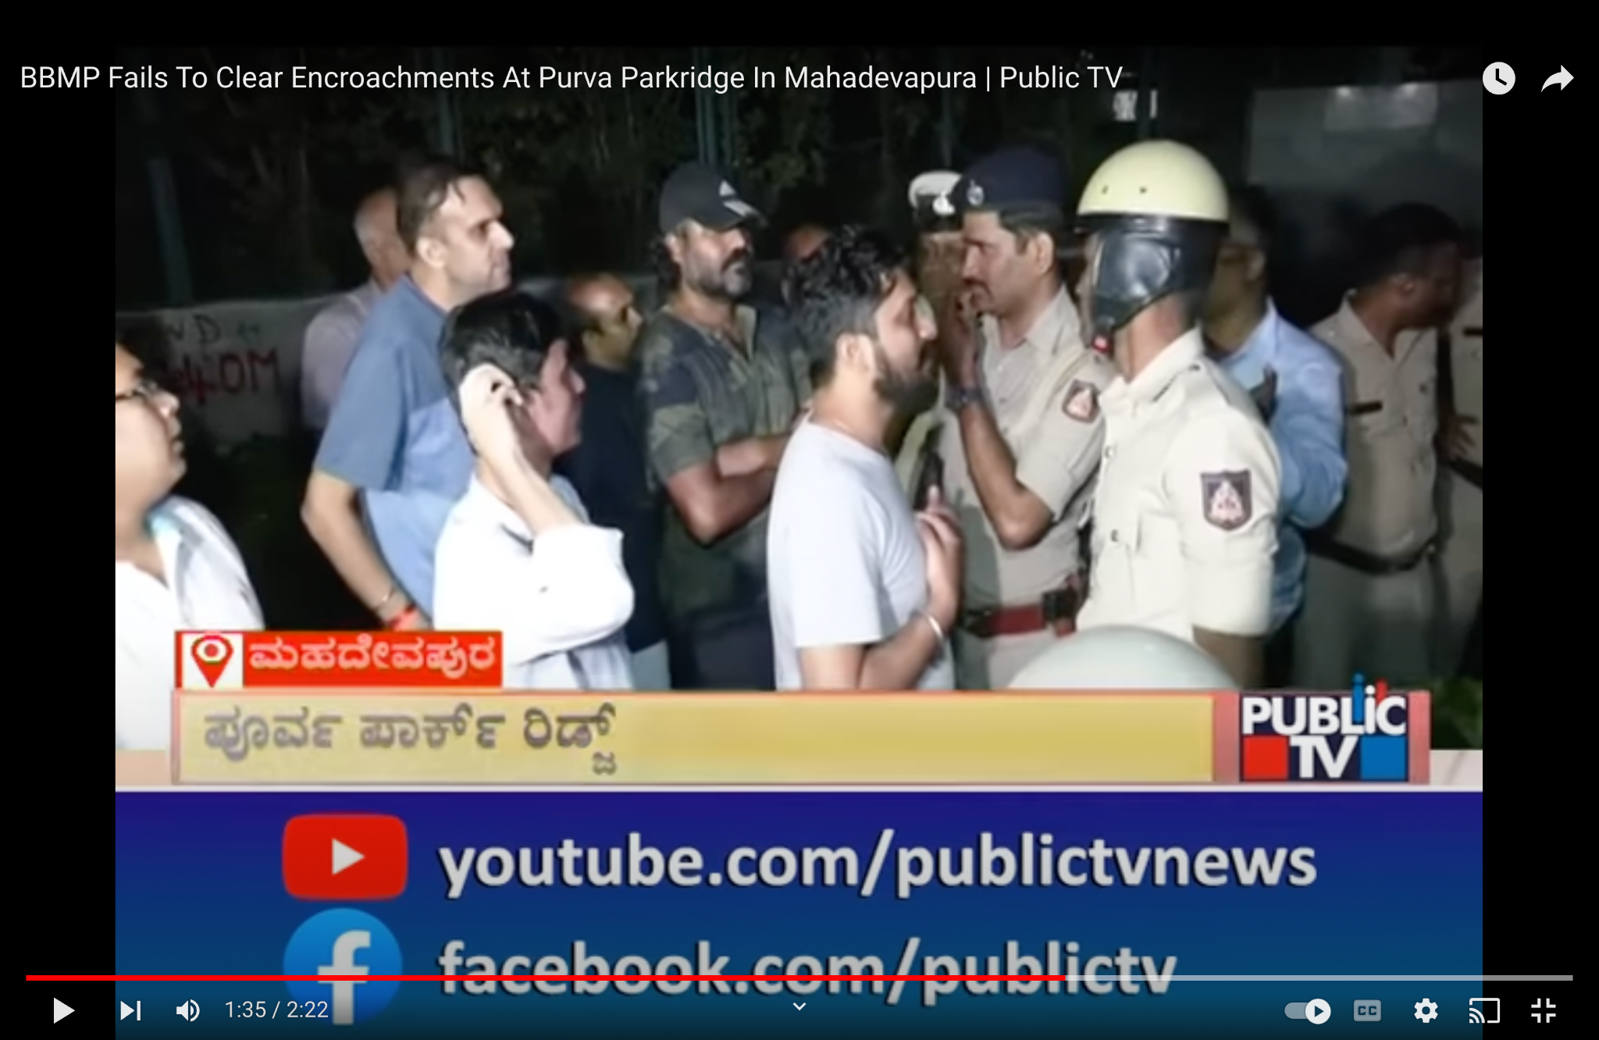
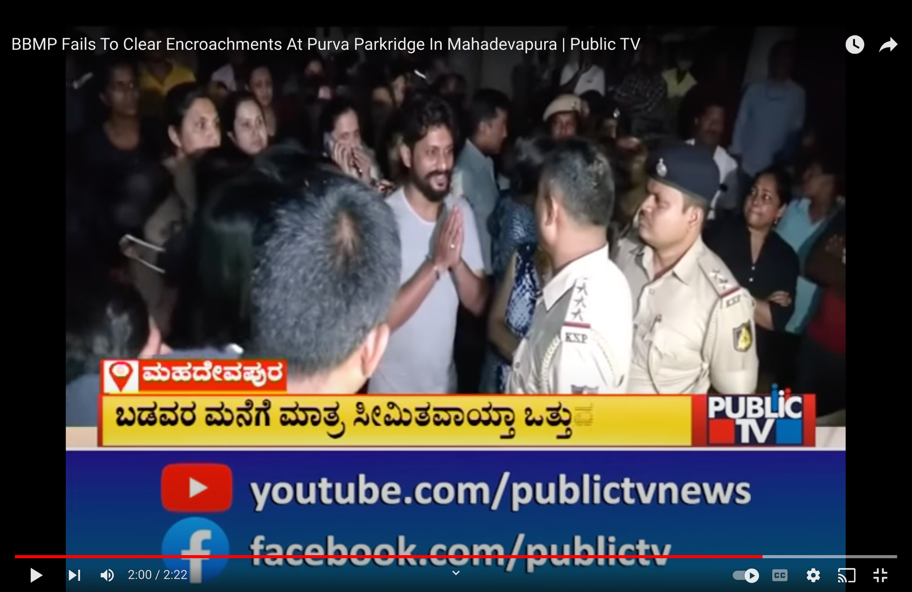

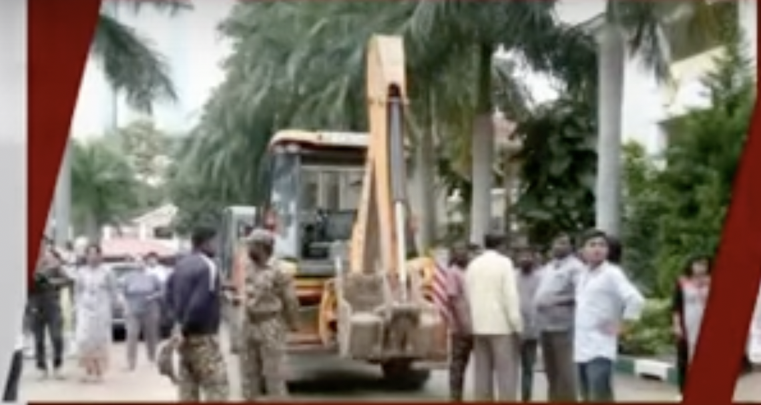

Resident 1: HUMAN CHAIN, make a human chain!!

Women surround the bulldozer, linking their arms together. Policemen put their heads together, and the municipal offer with them comes forward to put a big red cross on one of the houses.

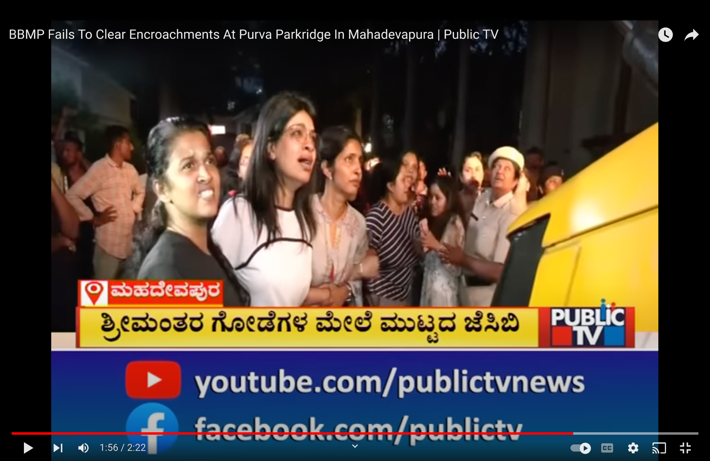

Resident 1: NO! These are our homes!
Resident 3: Go back!

One of the residents makes a call. DW looks closely at him as he yells into his phone.
Resident 4: It’s got to stop, I tell you! I don’t care, come down here yourself if you must!

Camera focuses on DW, in her plain grey clothing, seemingly dwarfed by this conversation.

Resident 4 walks up to policeman, thrusts the phone into his hands.
Resident 4: Here!

Policeman bends slightly to listen to the voice on the other end. Straightening up:
Policeman: Yes sir! Right away sir!

He gestures to the bulldozer to back away. The relieved residents break the chain, some of them gathering around Resident 4, some looking at their watches and walking back home. Just like that, the tension is diffused.

DW 1 is standing very still. DW 2 touches her hand, trying to lead her away from the scene.
Startled out of her reverie and shaking her head:
DW 1: Huh. Too bad that when it was our turn, nobody was there to receive the call. (Dialogue split over two panels. End).

