The story starts in the southern city of Daraa, Syria, commonly called the "Cradle of the Syrian Revolution", protests had been triggered on 6 March,2011 by the incarceration and torture of 15 young students from prominent families who were arrested for writing anti-government graffiti in the city, reading: "الشعب يريد إسقاط النظام" – ("The people want the fall of the regime") – a trademark slogan of the Arab Spring. The boys also spray-painted the graffiti "Your turn, Doctor"; directly alluding to Bashar al-Assad. Security forces swiftly responded by rounding up the alleged perpetrators and detaining them for more than a month, which set off large-scale protests in Daraa Governorate that quickly spread to other provinces. The Syrian Arab Army was soon deployed to shoot at the protests; resulting in a popular resistance movement led by locals; which made Daraa one of the first provinces in Syria to break free of regime control.
The characters are school students, security forces, policemen and protestors. The main character is one of the kids, he is interviewed. I am going to include quotes from him explaining how the spark of the revolution started and what happened when they drew the graffiti and being arrested.
I am thinking in presenting it in a way of flashback after a question asked to the main character. I am working on the layout of the story, but it is still as a draft. So, I am going to focus on the following steps:
- When the kids decided to buy the paint sprays
- Kids planning and drawing the graffiti
- Arrest from the regime security and policemen
- Demonstration and upraising in the governorate
- Spreading the upraising to the rest of the country (Map)

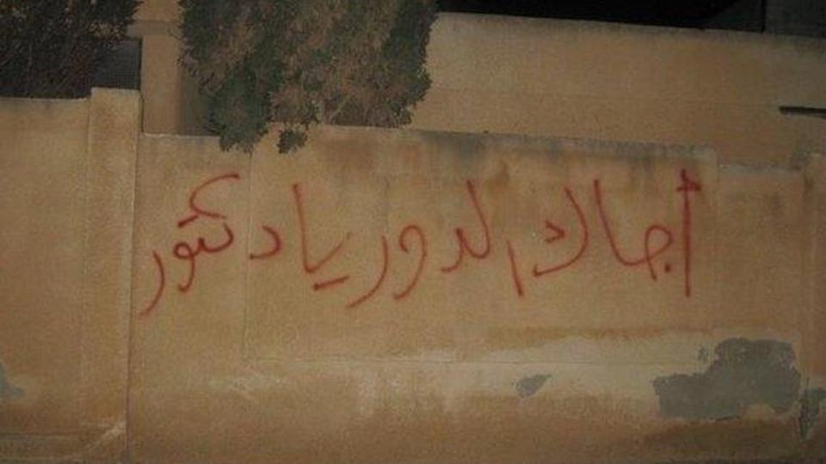
The graffiti photo

